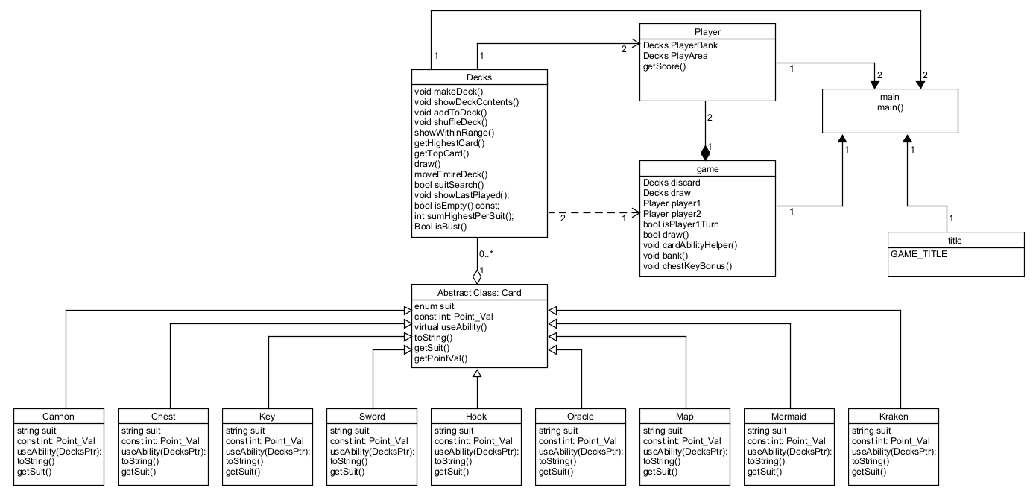

The reason why I coded the abilities for kraken and map in the fashion I did was because I believe in the literal sense, when I draw 3 cards it temporarily becomes a member in my play area. It is then up to the game which stores the player and by extension the play area to determine which cards stay and which cards go.

